**Daily Scrum or Standup Meeting**

Team name: _____Group 2____________________

Scrum Master: ____Max Edwards___________________

Date:____________________February 2___________

| **Team Member** | **What did you do since the last scrum?** | **What do you plan to do before the next scrum?** | **What obstacles do you have?** |
| --- | --- | --- | --- |
| Satchell | Started basic Django project Swapped function names to match what we need | Finish that Show us for Tuesday  Work on assignments from today | Nothing, should be chill |
| Jared | Activity diagram  Tutorial with the integration of Django and React | Work on assignments from today | Getting it work smoothly |
| Chase | Acitivty diagram | Work on assignments from today on Jira board | Make edits to activity diagram |
| Max | Setup basic React project | Work on UML diagrams | Enough time to do everything |
|  |  |  |  |

# Burndown

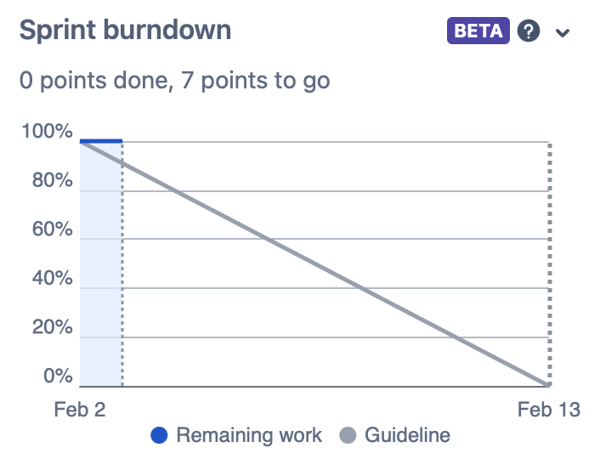

# Screenshot of you project board

